Windows Server 2016
Practical Assignment
Appendix B
DHCP Configuration
Version 1.0 (April 15, 2020)

You will be doing your tasks on server01.smithgreening.net, which is running Windows Server 2016. To access the server you will need a remote desktop client. If you require a refresher in how to access the server environment using Remote Desktop, please refer to the document CNA PPD – Windows Server 2016 – Practical Assignment – Appendix B – DHCP Configuration.pdf.
In the practical assignment you need to set some options for the scope for your office. You also need to make a reservation.
The options you need to set are the DNS server, and DNS domain name. To make these changes you need to login to the server, server01.smithgreening.net. You then need to follow the steps below.
- Run Server Manager
- On the Tools menu, select DHCP. This will launch the DHCP Server Manager, and you will be presented with the DHCP Management Console. You will then need to identify where the DHCP server is running. In our case, the DHCP server is running on server server01.
- On the Action menu, choose Add Server. Then check the option for “This authorized DHCP server”, and select server01, and press OK.
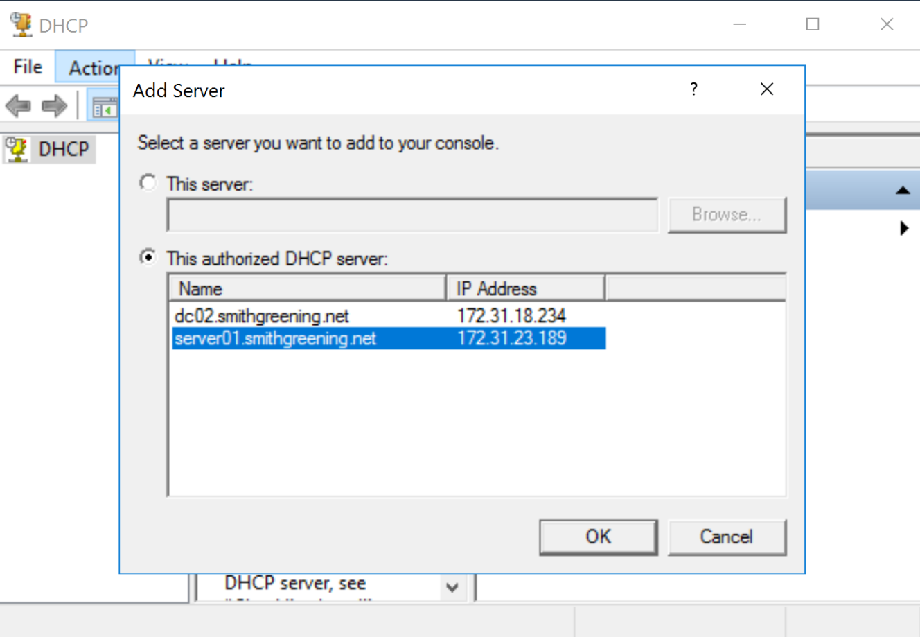
- Expand server01.smithgreening.net by clicking on it. The expand IPv4 by clicking on it. You should then see all the scopes which are active on the server, one for each branch office, including yours.
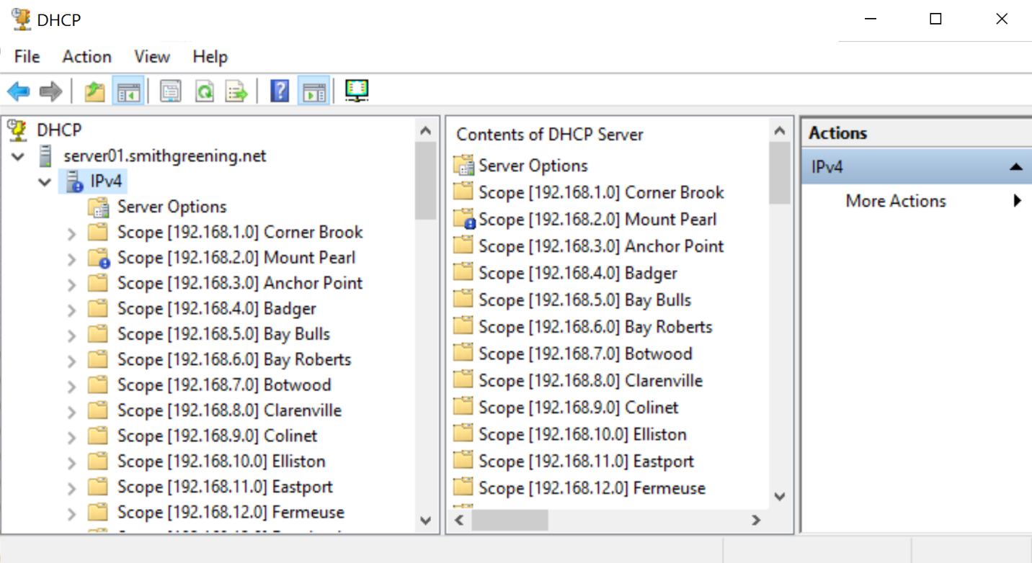
- Scroll down to the scope for your office and expand it by clicking on the scope. We will use Terra Nova as an example. Expand the scope by clicking on it, and then click on Scope Options. You will see that the only option set so far is the option for Router.
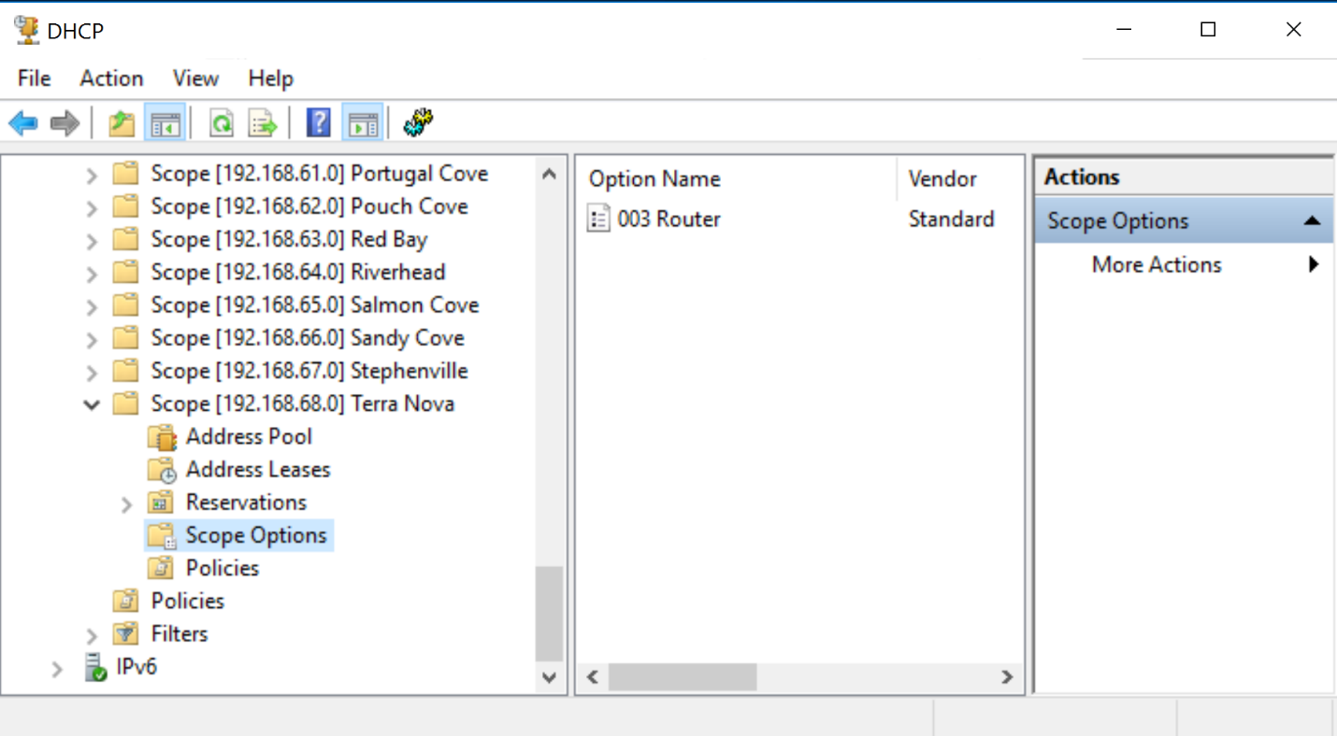
- By expanding the window you will see the values for the options set.
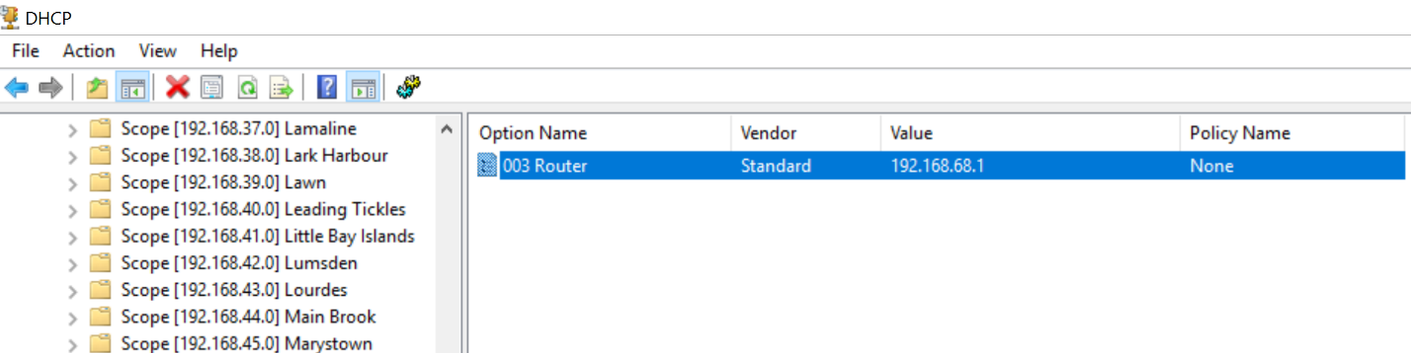
- Now you will add the options for DNS and DNS domain name. To add these, right click on Scope Options, and choose Configure Options. Then scroll down to option 006 DNS Servers. Check the box, which will then allow you to enter values for the DNS servers. We will enter one value, which is for our main DNS server dc01.smithgreening.net.
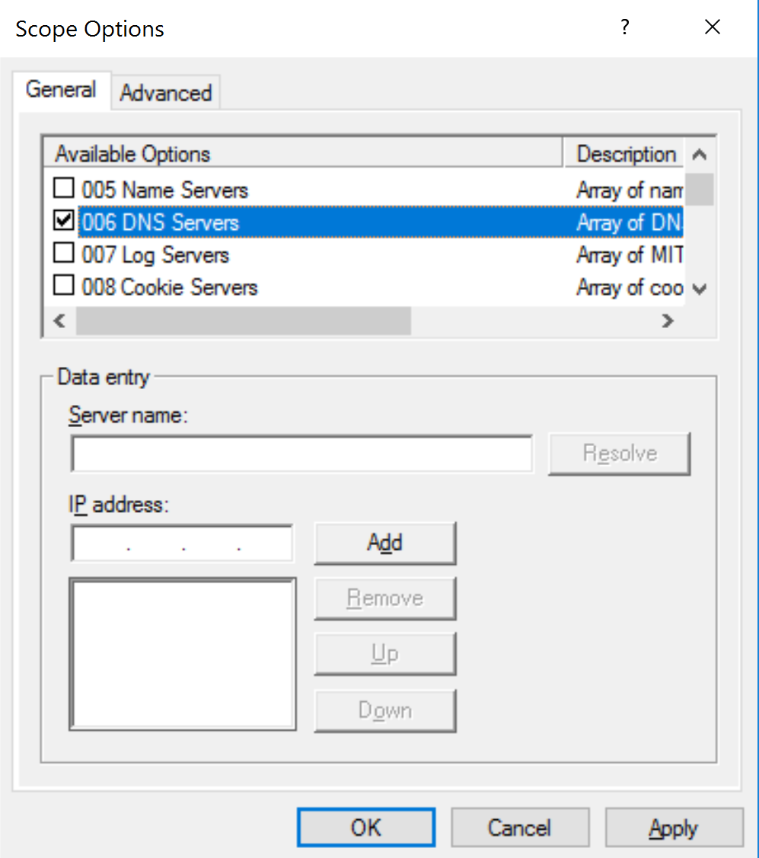
- Enter dc01.smithgreening.net in the Server name box and then click Resolve. It will then resolve the server name to its IP address for you. You MUST then click the Add button. Once you do click the Add button, you may see an information box display briefly indicating that it is verifying that there is a DNS server running on that server (which there is).
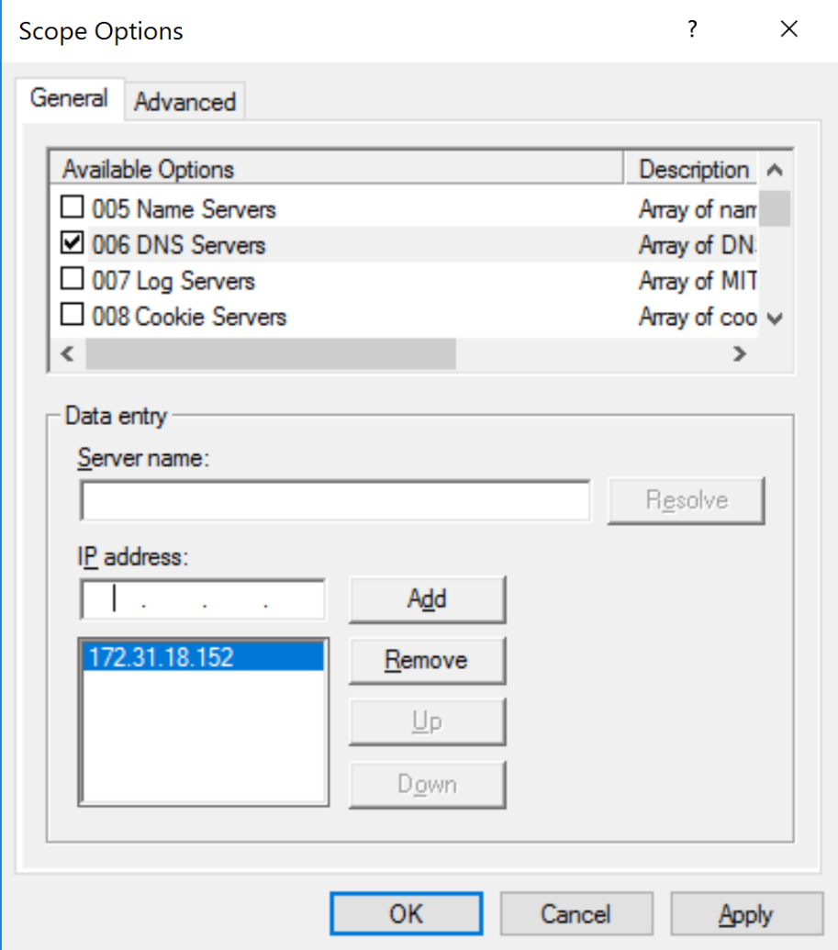
- Once you see the IP address of the DNS server populated in the box as you see above, you are ready to scroll down to option 015 DNS Domain Name, and click the checkbox next to it, type smithgreening.net in the String value text box and then you can click OK.
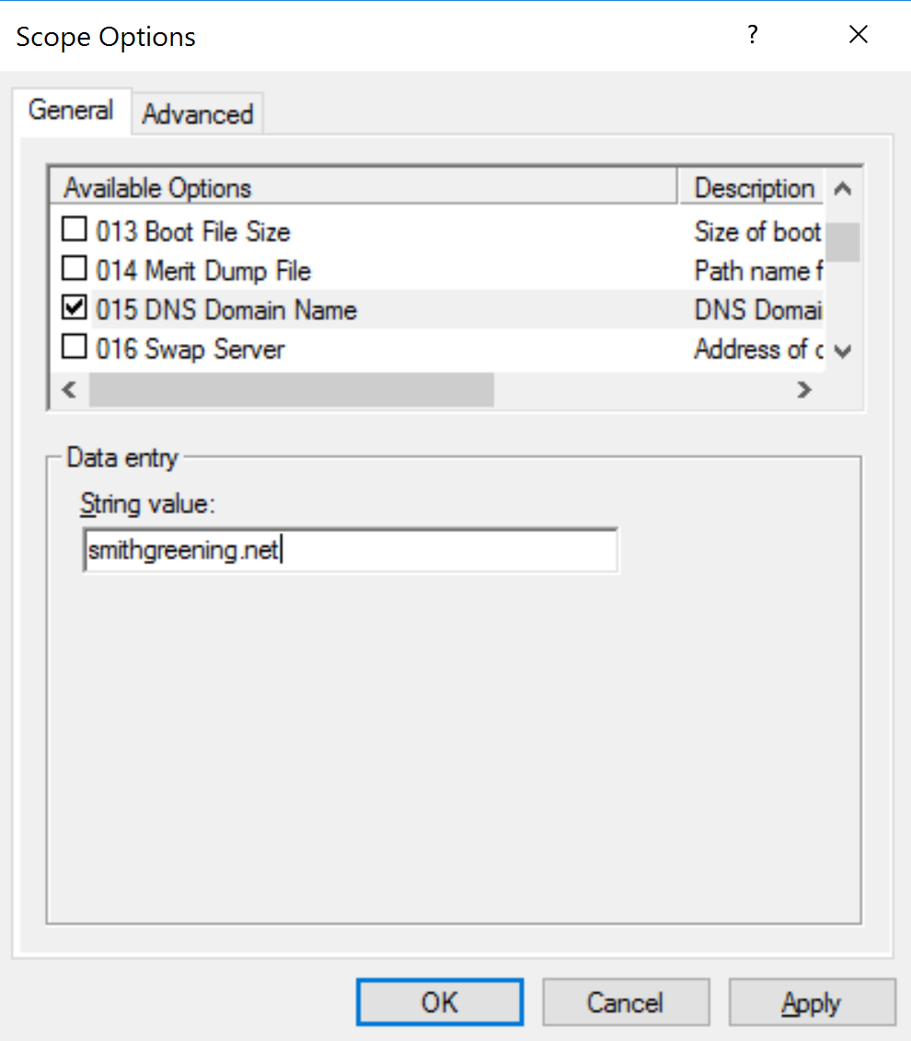
- You will then see the final DHCP Scope options similar to below.
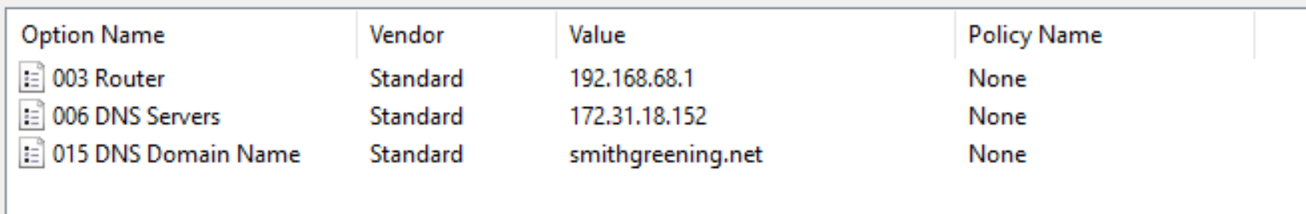
Please note that the IP address for the Router address WILL BE DIFFERENT in the scope for your office, as each office has its own IP address range. But the DNS Server and DNS Domain Name will be the same.
- You are now ready to create the DHCP reservation for the security camera. This is a short step. First, go to the Reservations heading under your Scope. Right click Reservations and choose New Reservation…
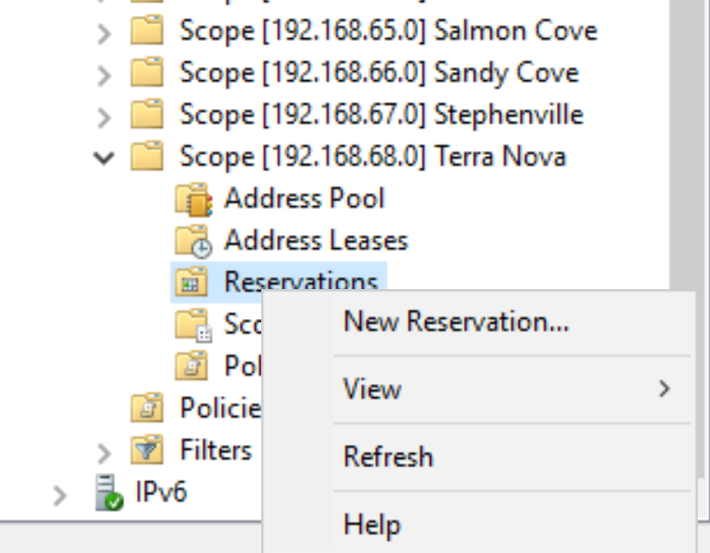
- Enter Security Camera in both the Reservation name and Description fields. Enter the IP address and MAC address from the table provided to you, finding the match for your office.
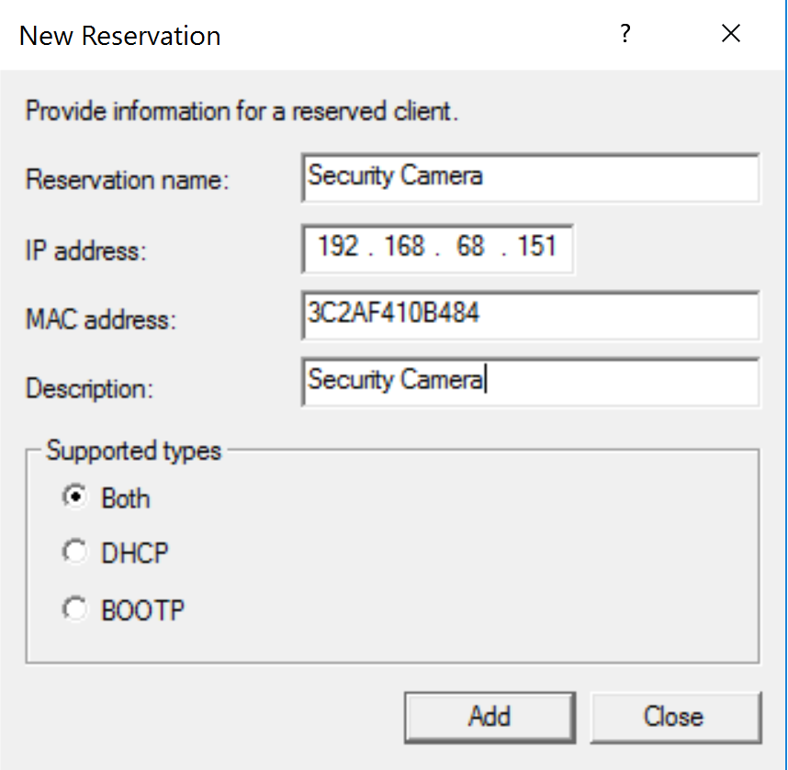
- You can then click the Add button which will complete your DHCP Configuration tasks!

